**Sprint 1:**

* **What went well?**

**Kyle**: Working with team to setup git on eclipse and determine how the classes with interact with each other for my section.

**Samuel**: Getting the project set up so that everyone could start contributing.

**Jeong**: Assigning tasks to each team member was done without any conflicts within the team.

**Akira**: We did well on planning the backlogs and the first sprint and this was our first hands-on practice on working according to Scrum.

* **What could have gone better?**

**Kyle**: My availability could have been better to complete my user stories in a more appropriate time.

**Samuel**: Agile values individual and interactions over process and tools, but I spent too long working on the javadocs for my part of the project and not enough time explaining it directly to the rest of my group.

**Jeong**: Our understanding of Git was quite limited, so I had difficulty pushing my local branch on Eclipse.

**Akira**: I didn’t finish all my tasks for sprint 1 before the sprint review, but I quickly finished them afterwards and got back on track.

* **What do we want to try next?**

Work on better communication about project goals and concepts.

**Sprint 2:**

* **What went well?**

**Kyle**: Fixing my user stories to comply with grading standards and committing my remaining user stories to master.

**Samuel**: This time around, the tasks had descriptions, assignees, point estimates, and sprint releases.

**Jeong**: I would say our communication. We mostly communicated via text messages and that way we were able to make progress simultaneously.

**Akira**: Everyone did their part and we made tremendous progress on adding more operations and refining the calculator’s innerworkings.

* **What could have gone better?**

**Kyle**: Once again, it would have been good to allow more time to complete my user stories sooner rather than later.

**Samuel**: It would have been nice to have had a finished product by this point, but we didn’t have enough done for it to work.

**Jeong**: Our time management. I think we could have completed our project a bit sooner.

**Akira**: I was having some problems with Git and I had no idea why. For some reason, Git merged some of my branches to and from the repository when I was actually trying to merge them locally on my hard drive.

* **What do we want to try next?**

Bug fixes, final touches, creating a finished product

1. **What was your team’s velocity for each sprint?**

|  |  |  |  |
| --- | --- | --- | --- |
| Sprint | Duration | Points | Average Points Per Day |
| Sprint 1 | 7 days | 18/18 | 2.57 |
| Sprint 2 | 7 days | 19/19 | 2.71 |
| Sprint 3 | 4 days | 12/12 | 3.00 |

1. 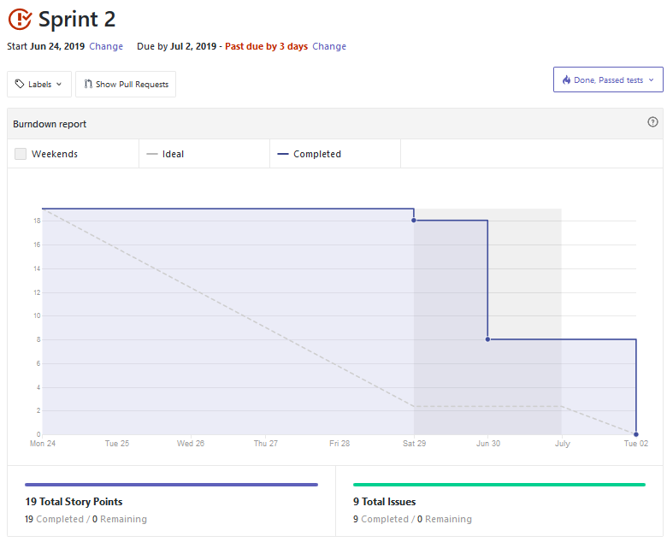**Sprint Burn Down Chart For Second Sprint**